Lab 2 - Patch Management

Brandon Trinkle

Arizona State University

IFT 380

Professor Shaun Usman

January 26, 2025

Lab 1 – Patch Management

1. System information
   1. Machine name: ASU-FRM1-APP024
   2. IP address: 10.10.141.240
   3. OS version: Microsoft Windows Server 2019 Datacenter - 10.0.17763 N/A Build 17763
   4. Memory: 8,090 MB
   5. Processor: Intel64 Family 6 Model 85 Stepping 7 GenuineIntel ~2500 Mhz

1. Copy utility to desk top and display logs:

1. Successful installation

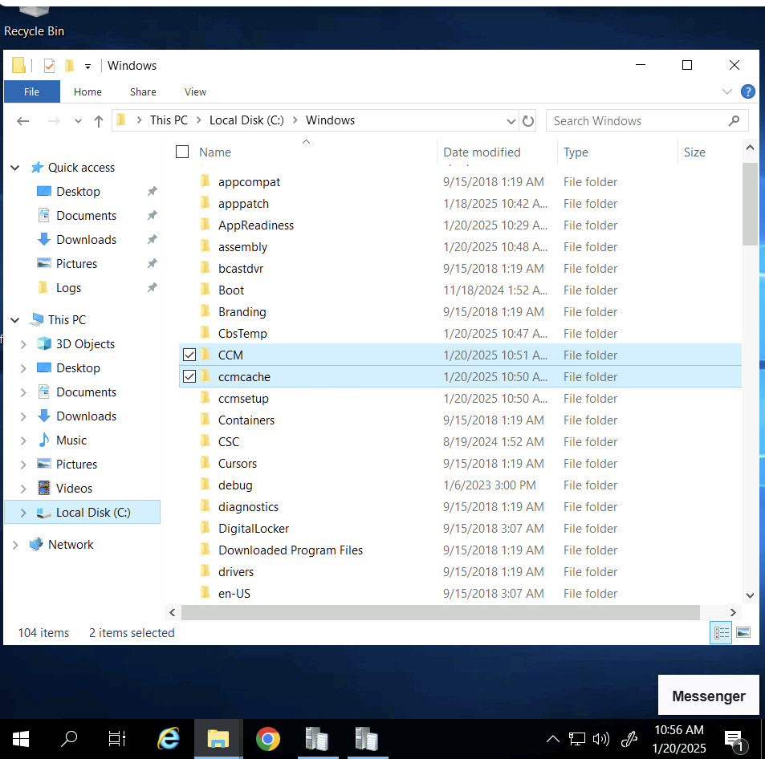

1. Configure SCCM adavanced client:

1. Software center

1. Install SCCM Admin Console:

1. Create a collection:

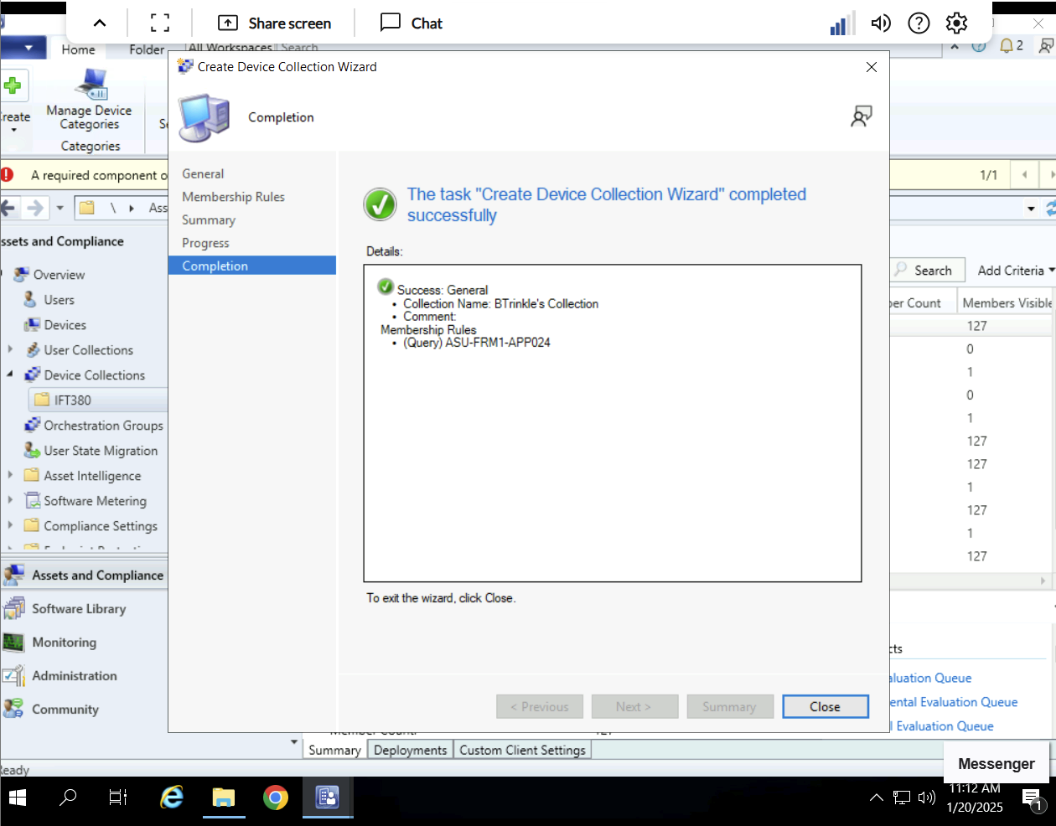

1. Test remote connection to ASU_Instructor PC

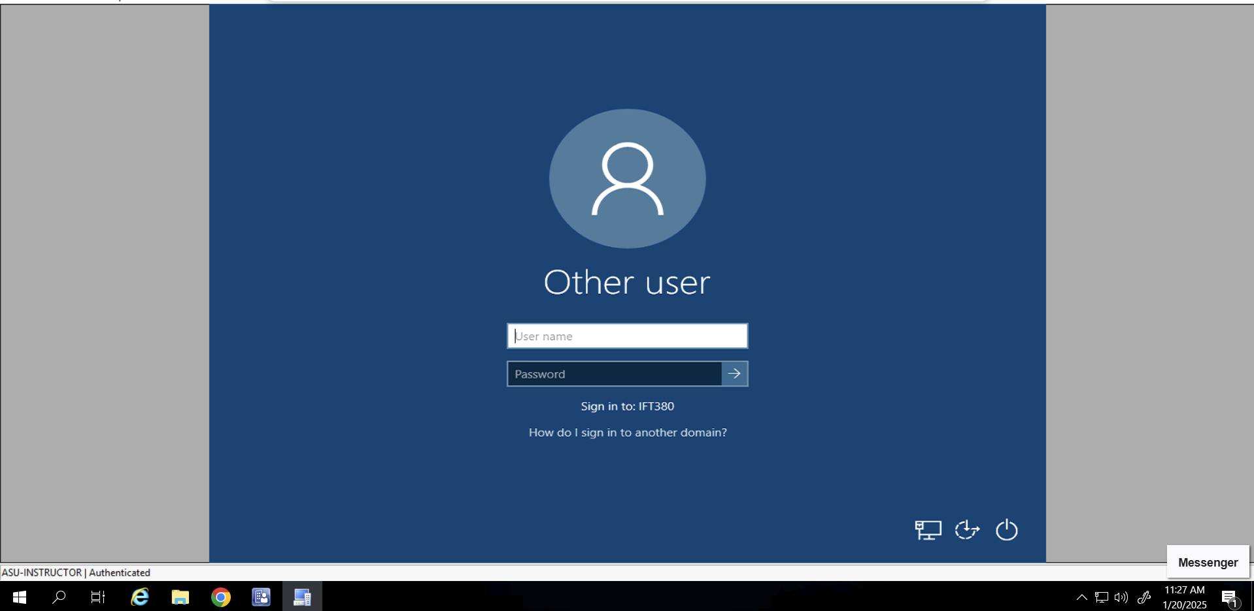

*Note: Login credentials were not provided in Lab instructions.*

*Note: Attempted access to bapere12_ift380*

1. Client configuration settings

1. Install Active Directory Users and Computers

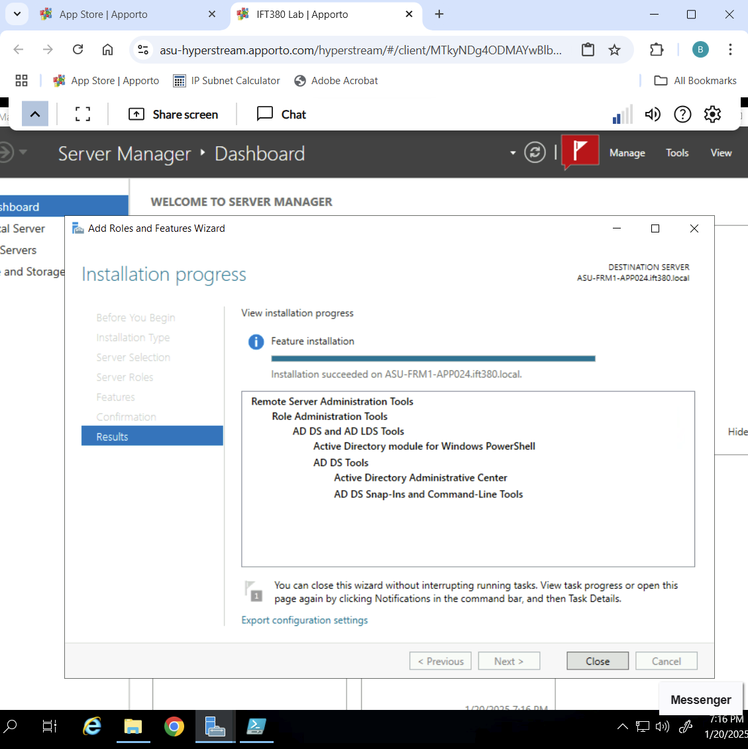

*Note: Utilized the Lab 1 teams channel for support.*